Technical Visit to Macau – Macau Light Rail East Line (South Section) and Wynn Palace (Jointly Organised with CPDC)

By Mr. Tom Wong

On 7 March 2026, the HKIE Young Members Committee organised a one-day technical exchange tour to Macau, providing participants with first-hand exposure to large-scale tunnelling works and complex resort facility operations. Over 30 young engineers joined the visit, which comprised a site tour of the Macau Light Rail East Line (South Section) and a tour of Wynn Palace.

The first visit was the Macau Light Rail East Line South Section, an important infrastructure project that includes the territory’s first cross-harbour tunnel alignment. The project team provided an overview of the alignment, construction sequence and the measures taken to ensure reliability and public safety for the underwater section and adjacent works. A focal point was the tunnel boring machine (TBM) “澳氹一號”, a shield-type TBM used for submerged tunnelling with segmental lining installation. The briefing covered TBM’s working principle: rotating cutterhead excavation, spoil removal systems, on-board face support and automated segment erection, plus steering and monitoring systems.

The second visit was to the Wynn Palace. During the visit, the speaker from Wynn Palace introduced the Public Attraction Workshop and Wynn Training Academy, emphasising integrated operations and preventive maintenance. Then, a visit to the Performance Lake plant and equipment rooms was arranged. Next, the SkyCab control room and drive room were visited to showcase the control logic and safety systems. Participants also took a round trip from Second Floor Station to Street Station and back, observing station design and passenger operations.

Overall, the one-day technical visit has proved to be an enriching experience for all participants, fostering a deeper understanding of cutting-edge technologies and their practical applications in various industries. We would like to thank all the companies involved for their warm hospitality and informative presentations, inculding Macao Institution of Electrical & Mechanical Engineers (AEEMM), China State Constriction (HK), China State Constriction (Macau), STEC (Macau) and Wynn Palace. We look forward to organising more such events that encourage knowledge sharing and professional growth among our members.

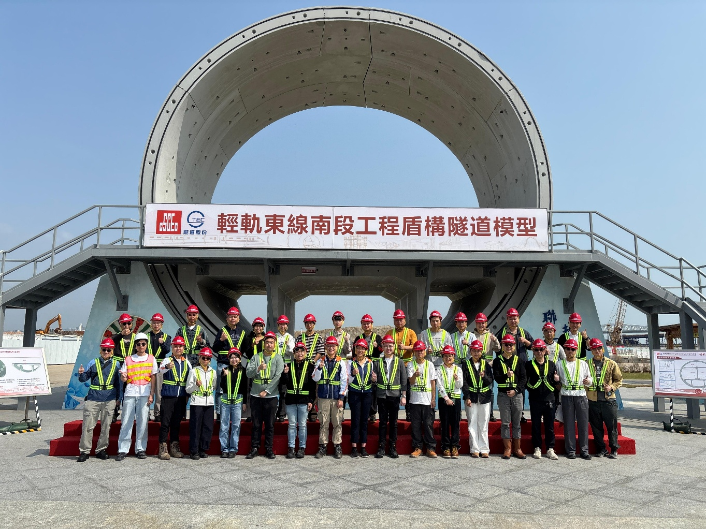
Figure 1 – Group Photo of the Participants

