Volunteering Service on Visiting Seniors in Winter: 寒冬送暖顯溫情 2025

By Mr Jerry Chan

On 13 December 2025, the HKIE Young Members Committee (YMC), in collaboration with The Law Society of Hong Kong, successfully co-organised the community outreach programme “寒冬送暖顯溫情 2025” in partnership with Yang Memorial Methodist Social Service – Kingsford Terrace Centre. The initiative was designed to bring warmth and companionship to elderly residents in Wong Tai Sin during the winter season, and approximately 500 elderly individuals across the Choi Hung and Choi Wan areas received support through this visit.

Volunteers were organised into small teams to conduct home visits to the elderly residents. During these visits, teams delivered winter care packs containing essential items such as warm clothing, heat packs, and other necessities to help the residents stay comfortable in the colder weather. At the same time, volunteers engaged in face-to-face conversations and friendly check-ins, offering emotional support, listening to stories, and fostering a genuine sense of connection and care. The interactions were filled with warmth, and many residents expressed their appreciation through bright smiles and heartfelt words such as “thank you for coming”.

The programme not only provided practical assistance but also highlighted the profound importance of intergenerational connection, community solidarity, and proactive care for vulnerable members of society, especially during the winter months. The positive responses and gratitude shown by the residents underscored the deep and meaningful impact that such personal outreach efforts can have.

We extend our sincere appreciation to all the volunteers who participated with dedication and boundless energy, to Yang Memorial Methodist Social Service – Kingsford Terrace Centre for their excellent coordination and warm hospitality, and above all to the elderly residents themselves for welcoming us so openly into their homes. Their contributions made the event both successful and deeply rewarding for everyone involved.

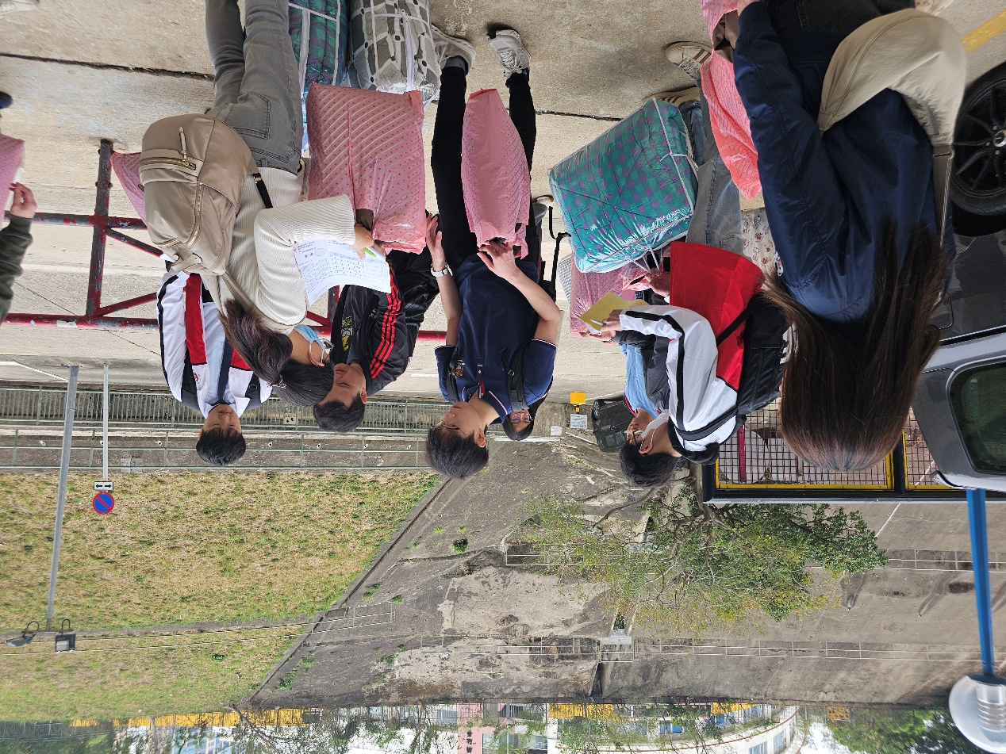
Figure 1 – Helpers preparing for the home visits
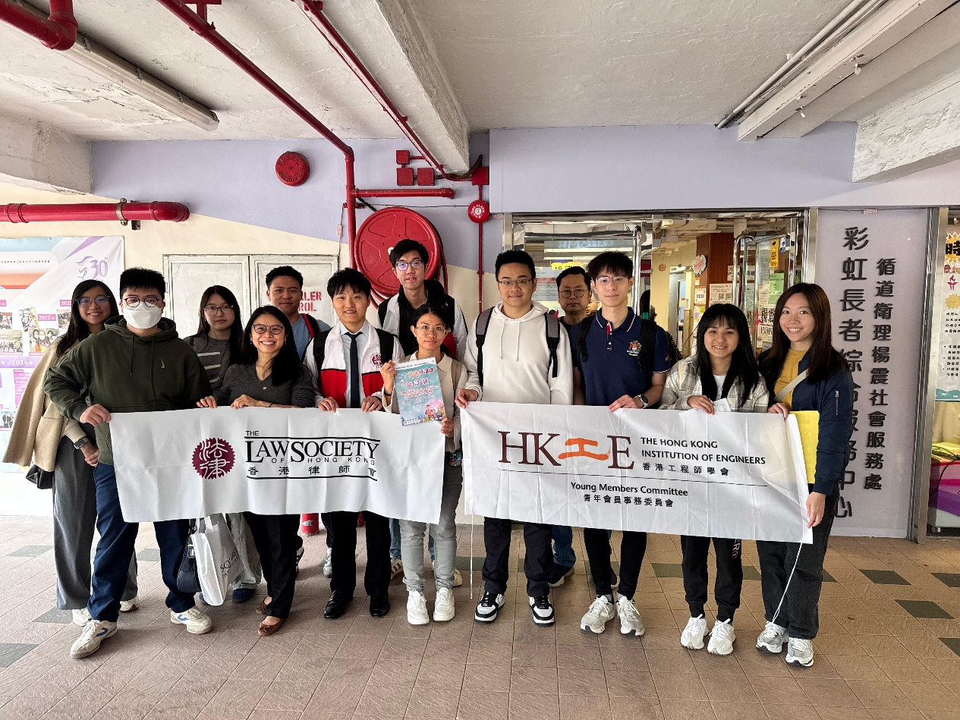
Figure 2 – Group photo of YMC and The Law Society of Hong Kong

